***Elegance Hair***

***Saloon***



*This is to certify that the dissertation*

*entitled “Elegance hair saloon” is*

*submitted by* ***Zamzam Student1445114****,*

***Wasif Student1429176****,* ***Mubeen Student1446617 Abubakar Student1407848*** *and*

***Student1422535***

*in their partial fulfilment of the*

*requirement of the award of the Aptech*

*Computer Certified.*

***ACKNOWLEDGEMENT***

*The success and final outcome of this project required a lot of guidance and assistance from many people and I am extremely privileged to have got this all along the completion of my project. All that I have done is only due to such supervision and assistance and I would not forget to thank them.*

*I respect and thank Aptech for providing me an opportunity to do the project work in ACE and giving us all support and guidance, which made me complete the project duly. I am extremely thankful to Aptech for providing such a nice support and guidance. I owe my deep gratitude to our project guide Sir Ebad-Uddin-Ahmed, who took keen interest on our project work and guided us all along, till the completion of our project work by providing all the necessary information for developing a good*

*system.*

***TABLE OF CONTENT***

*Certificate*

*..........................................................................................3*

*Acknowledgement............................................................4*

*AbstracT…….....................................................................5*

*CHAPTER # 1*

*........................................................................................6*

*INTRODUCTION*

*.........................................................................................7*

*CHAPTER # 2*

*....................................................................................... 9*

*FUNCTION REQUIREMENT*

*........................................................................................10*

*CHAPTER # 3*

*....................................................................................... 11*

*REQUIREMENT SPECIFICATION*

*....................................................................................... 12*

*CHAPTER # 4*

*.......................................................................................14*

*ANALYSIS*

*......................................................................................15*

*CHAPTER # 5*

*...................................................................................... 20*

*DESIGN*

*....................................................................................................................................................................... 20*

*CHAPTER # 6*

*.......................................................................................................................................................................27*

*TESTING*

*......................................................................................................................................................................27*

*CHAPTER # 7*

*...................................................................................................................................................................... 31*

*SCREEN SHOTS*

*.......................................................................................................................................................................31*

*Create Account*

*......................................................................................................................................................................32*

*Home Page Header*

*.........................................................................................................................................................................34*

*Footer*

*......................................................................................................................................................................... 34*

*Weight Converter*

*......................................................................................................................................................................... 35*

*Industries*

*......................................................................................................................................................................... 35*

*About*

*Us.....................................................................................................................................................................36*

*Our Services*

*.......................................................................................................................................................................36*

*Track Your Order*

*..........................................................................................................................................................................37*

*Create A Shipment*

*..........................................................................................................................................................................37*

*Contact Us*

*....................................................................................................................................................................... 38*

*Login*

*..................................................................................................................................................................38*

*CHAPTER # 8*

*.................................................................................................................................................................... 39*

*TASK SHEET*

*........................................................................................................................................................................39*

*TASK SHEET*

*.................................................................................................................................................................... 40*

*CHAPTER # 9*

*....................................................................................................................................................................41*

*SUBMISSION CHECKLIST*

*................................................................................................................................................................... 41*

*Conclusion*

*...................................................................................................................................................................... 43*

***INTRODUCTION***

*Elegance Salon is a popular beauty establishment that offers a variety of services including hair*

*styling, manicures, pedicures, and facials. The salon is facing challenges in efficiently managing*

*appointments, handling inventory, and maintaining client records.*

*Salon management application will enhance operational efficiency, improve customer*

*experience, and streamline business processes for Elegance Salon. By addressing the specific*

*needs of appointment management, client relations, inventory control, and staff scheduling, the*

*salon can optimize its operations and focus on delivering exceptional services to its clientele.*

***FUNCTIONAL REQUIREMENTS***

*The following are the key features and functionality expected from the application:*

***HOME PAGE:***

*The home page should be designed to provide an engaging and informative experience for*

*users. It should display information about the Elegance Salon with some images.*

***USER AUTHENTICATIONAND ACCESS CONTROL***

*The system should support different user roles (admin, receptionist, stylist) with distinct access*

*permissions.*

*Users should log in securely using username/email and password authentication.*

***APPOINTMENT MANAGEMENT***

*Users can view available time slots for different services.*

*Ability to book, reschedule, or cancel appointments.*

*Automated confirmation notifications (email/SMS) for booked appointments.*

***CLIENT MANAGEMENT***

*Maintain a centralized client database with details like name, contact information, services*

*availed, and appointment history.*

*Allow searching, adding, editing, and deleting client profiles.*

*Record client preferences for specific stylists or services.*

***INVENTORY MANAGEMENT***

*Track inventory levels for salon supplies (e.g., hair products, beauty supplies).*

*Receive alerts for low inventory and generate automatic purchase orders.*

*Record supplier information and cost details for inventory items.*

***Project Group Members***

|  |  |
| --- | --- |
| ***Student***  ***ID*** | ***Student Name*** |
| ***Student1445114*** | ***Zamzam*** |
| ***Student1429176*** | ***Wasif*** |
| ***Student1446617*** | ***Mubeen*** |
| ***Student1407848*** | ***Abubakar*** |
| ***Student1422535*** | ***Waqar*** |

***CURRICULUM:7602***

***BATCH :2212C2***

***FACULTY NAME:***

***Ebad-uddin-ahmed***

***CO-ORDINATOR: Miss Sana***

***USER REGISTERATION FORM***

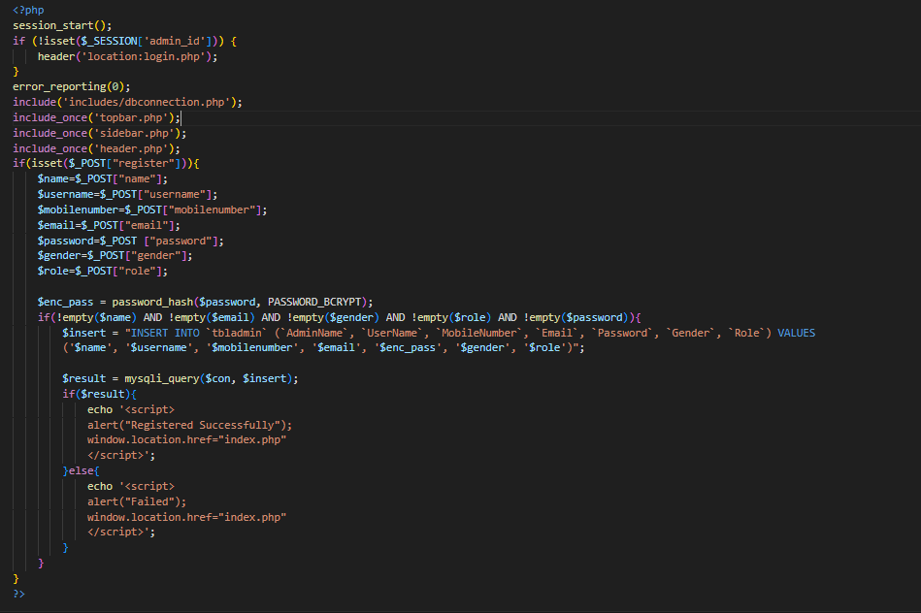

***USER LOGIN FORM***

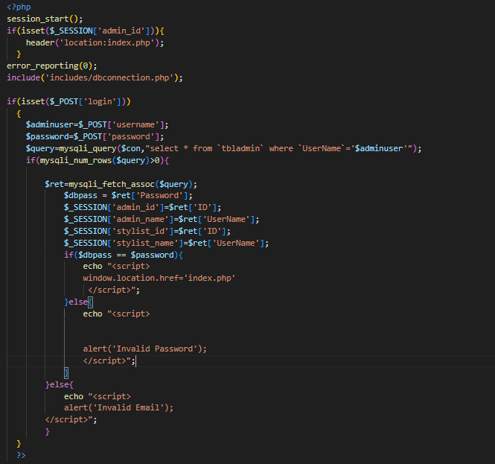

***CHANGE PASSWORD***

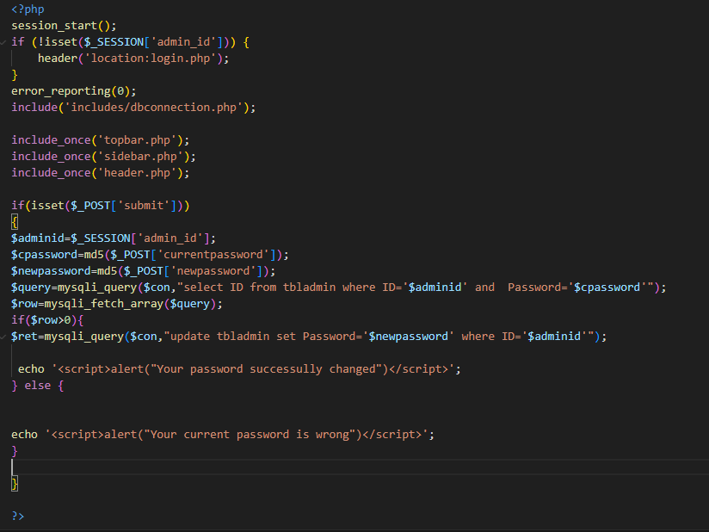

***FORGET-PASSWORD***

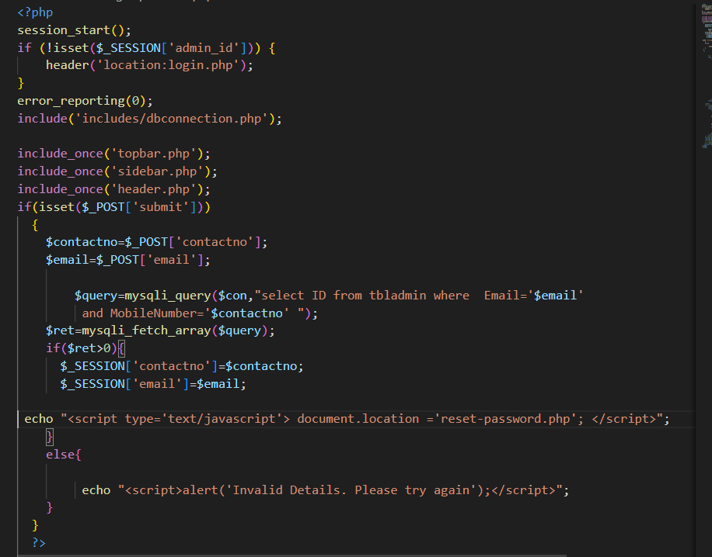

***APPOINTMENT FORM***

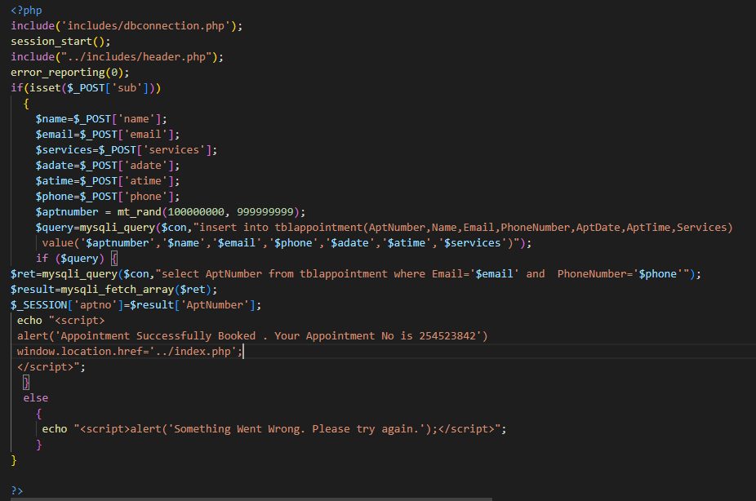

***ADD CUSTOMER SERVICE***

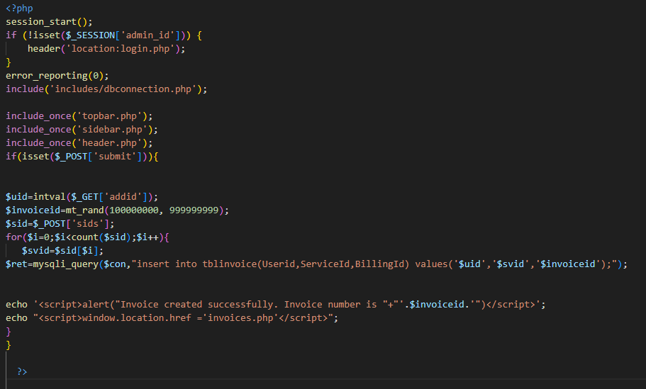

***ADD CUSTOMER***

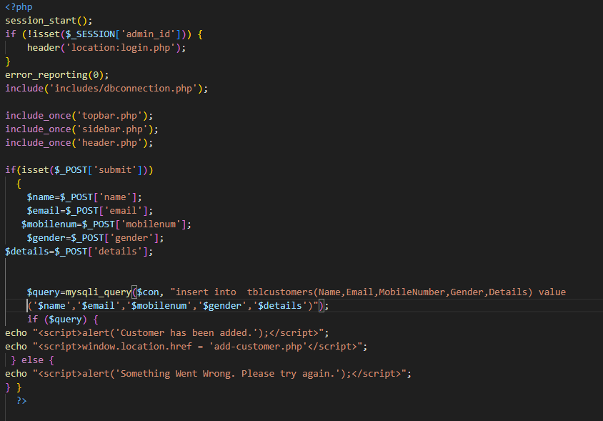

***ADD SERVICE***

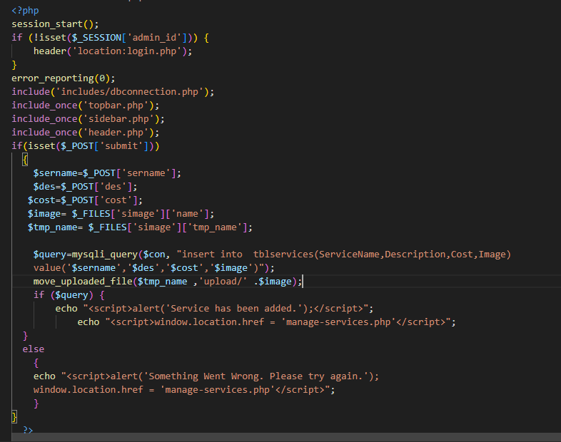

***EDIT-SERVICE***

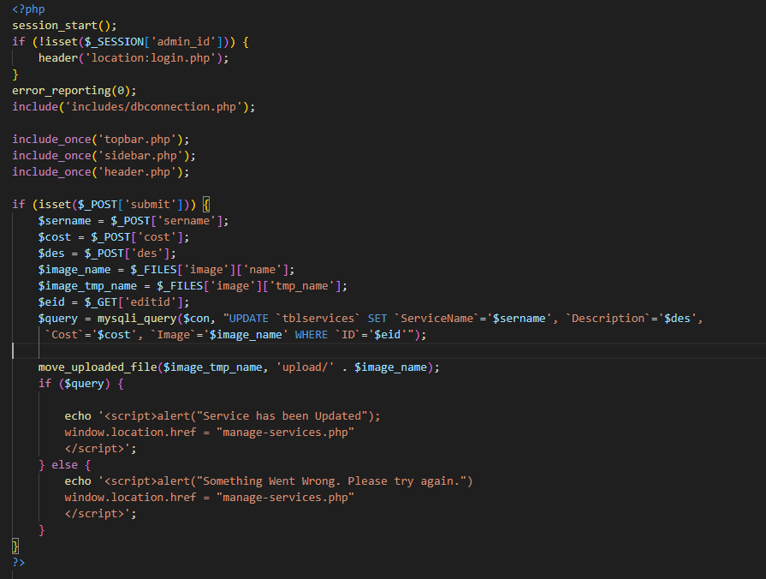

***ADD STAFF***

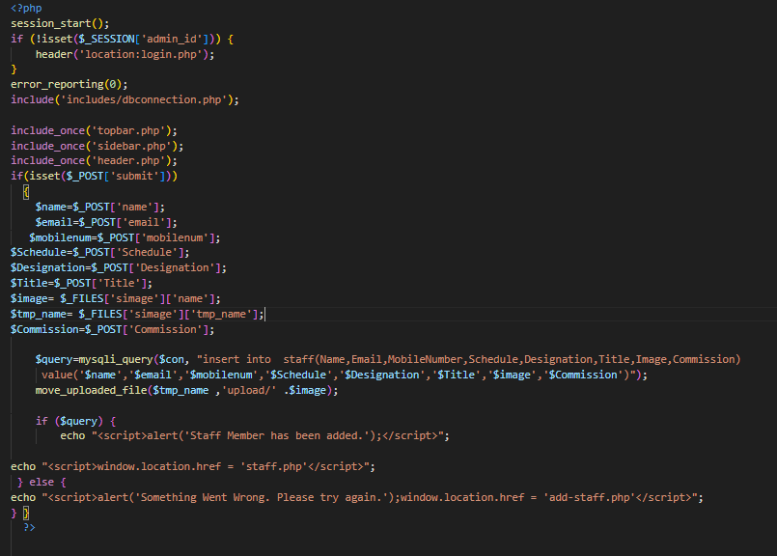

***EDIT-STAFF***

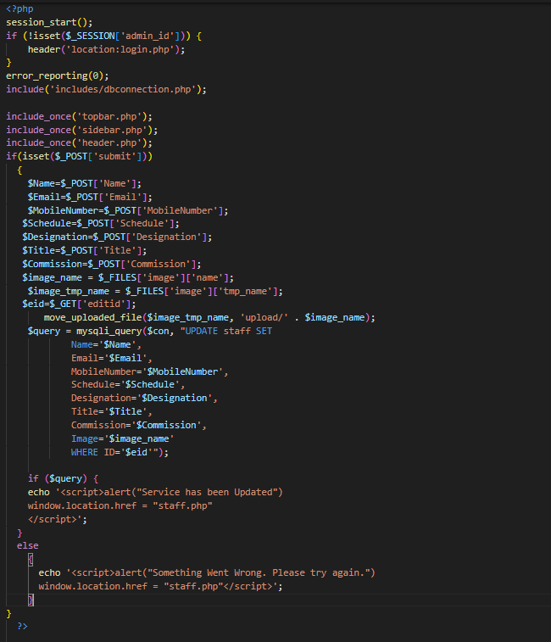

***ADD PRODUCT***

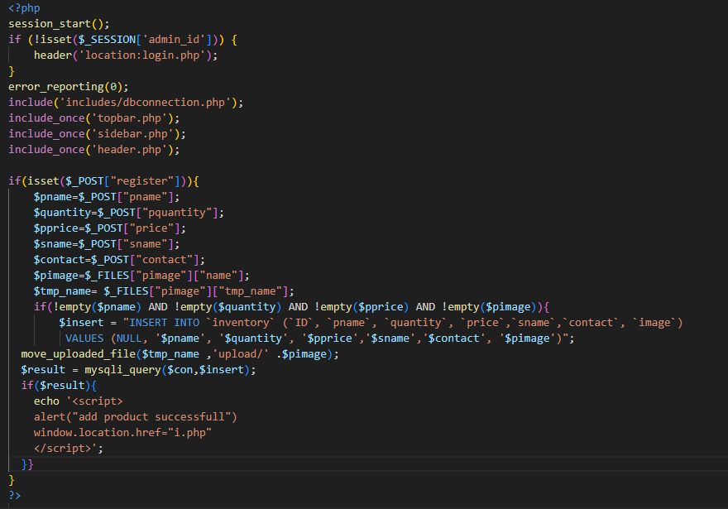

***ALL APOINTMENT***

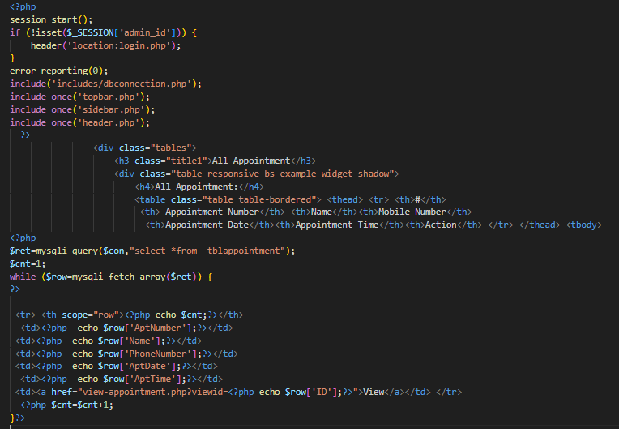

***CUSTOMER LIST***

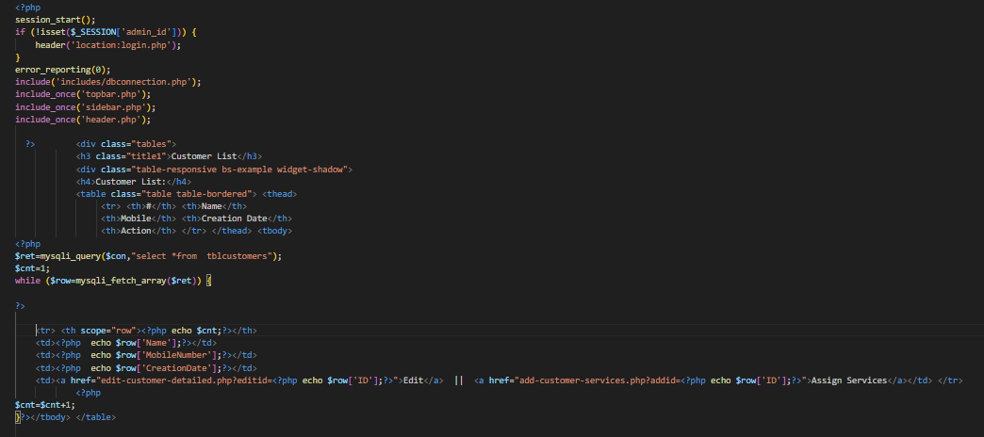

***EDIT-CUSTOMER DETAILS***

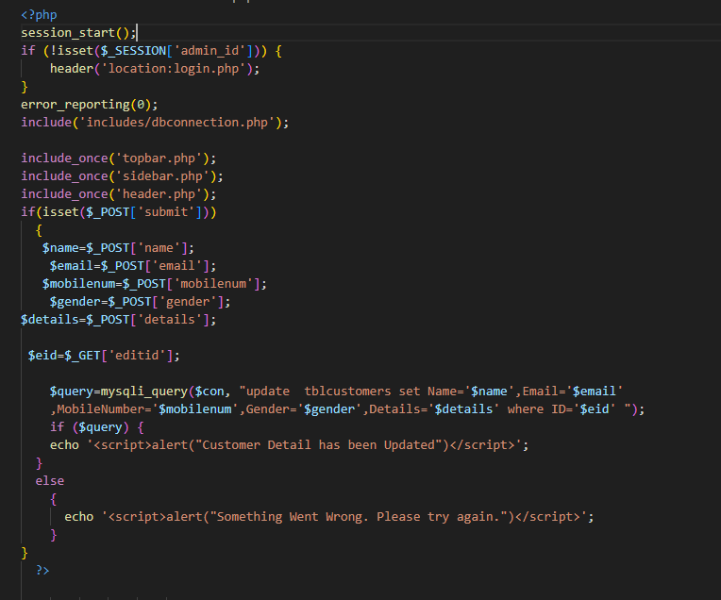

***INVENTORY***

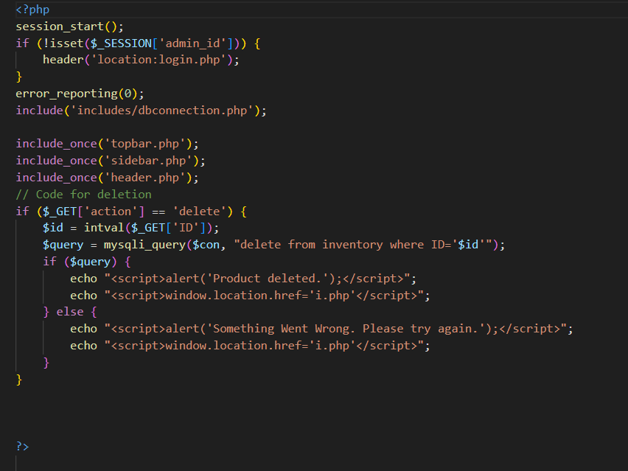

***EDIT INVENTORY***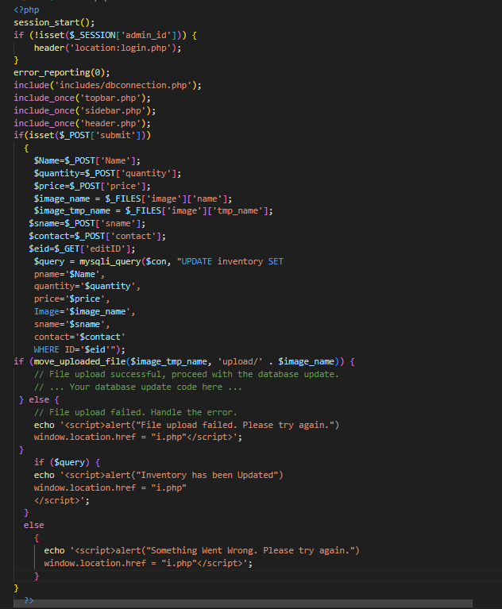

***INVOICE***

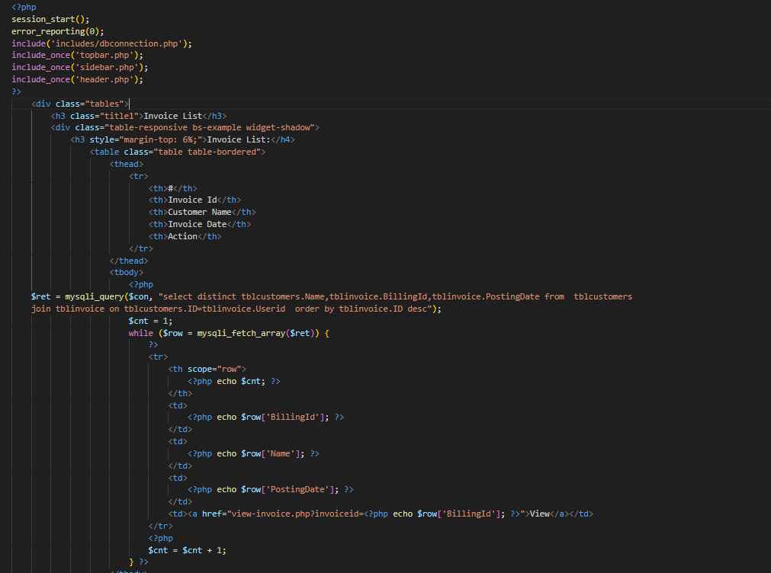

***MANAGE-SERVICES***

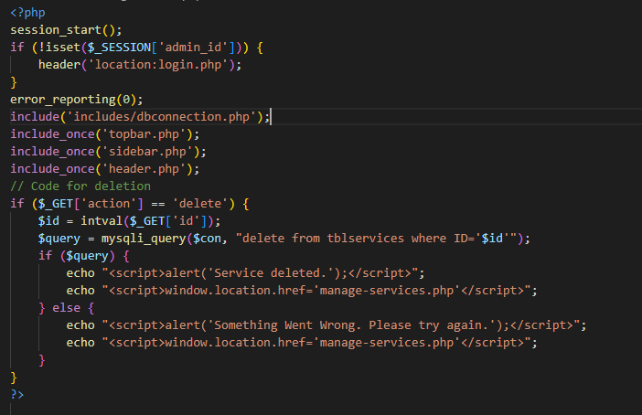

***SEARCH -APPOINTMENT***

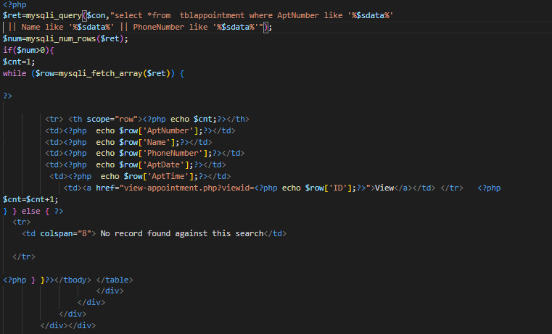

***STAFF-CATEGORY***

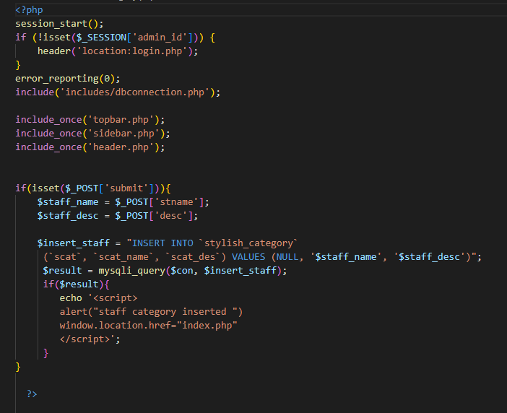

***SUBCRIBERS***

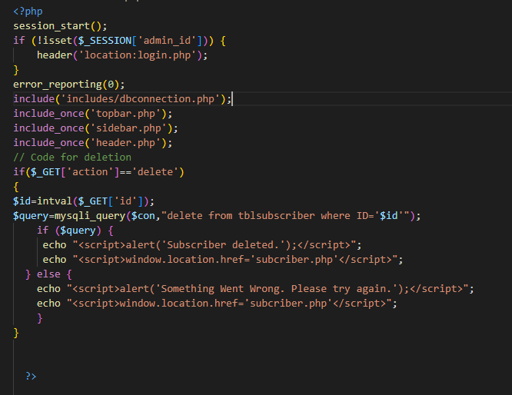

***VIEW APPOINTMENT***

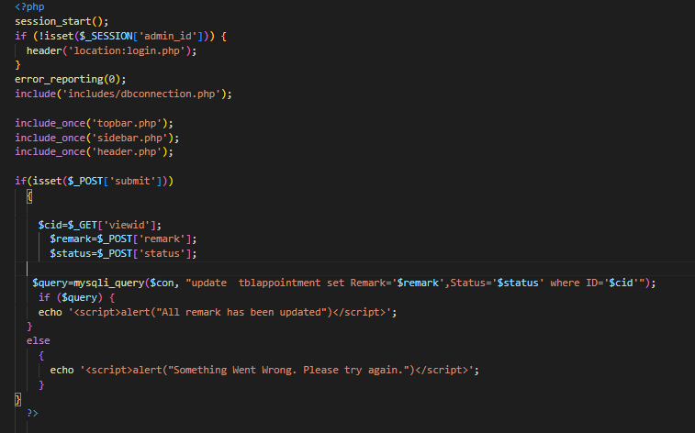

***VIEW INVOICE***

